2022 Reserved Painted Parking Spaces Student Contract

Name: _________________________________________________ Phone #:______________________
Address: _____________________________________________________________________________
License Plate Number: _______________________________ Parking Permit Number: _____________

I hearby agree to abide by all of the following rules and regulations corresponding to my privilege of having a reserved painted parking spot.
- Upon purchasing my reserved painted parking spot, I will only use water-based exterior latex paint to paint my design
- I understand that I must check-in with a PSO Chair-Person or PSO President to confirm my assigned parking spot
- I know I am not allowed to use spray paint, reflective paint, or fluorescent paint of any kind.
- I will only paint within the marked parking space that is assigned to me.
- I know I have to bring my own brushes and painting supplies to decorate my spot.
- I will never park in another parking space that is assigned to someone else or let anyone park in my space.
- I will only paint my approved design, following all the guidelines, in my parking space.
- I understand that my painted design must be completed by the end of the session on Sunday, August 28, 2022.
- If I park in someone else’s painted parking spot, I may receive disciplinary action.
- I will place a signed sticker on my parking pass to visually allow school guard to identify cars with permission to park in painted spots.

______________________________________ _______________________
Student’ Signature Date

_______________________________________ _________________________
Guardian’s Printed Name Guardian’s Phone #

_______________________________________ ________________________
Guardian’s Signature Date

Senior Parking Design Request  Student Name:  _____________________________________________ | 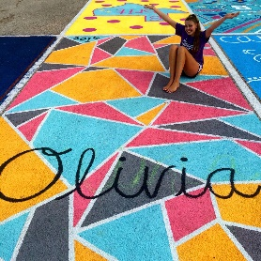
This design sheet must be done in color and must represent exactly what will be painted on your parking space to be accepted.

******* 2 inch border required around your design and white parking lines********

Office Use Only: Assigned Parking Space Number: ___________________

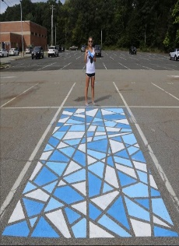 | 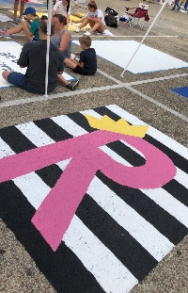 | 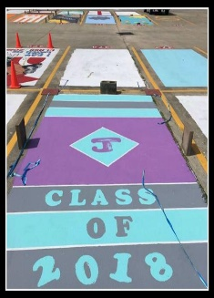 | 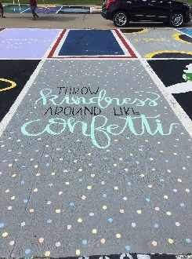 | 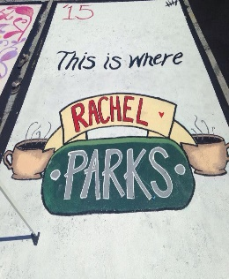 | 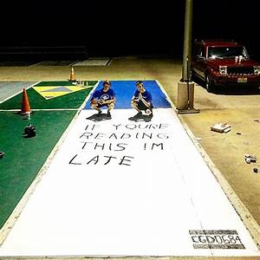
Senior, you can Personalize your Parking Spot!
Come have fun with your friends and show your BBHHS spirit and class pride by painting on your own personal cement canvas! This PSO fundraiser will help provide extra items for the High School for you to enjoy! (e.g. the Senior Lounge, live-stream equipment, etc)
- First, complete this application with your intended design and pay $25.00 when you come to pick your spot. Please make checks payable to BBHHS PSO
- Pick your Spot when you pay!
- You will paint your spot on Saturday, August 27 and Sunday, August 28
Guidelines for your sketch:
Think of your parking spot as a t-shirt that you want to wear to school. Your spot must be in dress code – so NO references to drugs, alcohol, smoking, gangs, etc. Keep it Classy! You can use your name, include your jersey number, an instrument you play, or favorite hobby to name a few ideas! Your spot should be fun and reflect who you are.
Paint Requirements:
- Paint must be latex “liquid” paint, water-based exterior latex works best. NO spray, reflective or fluorescent paint permitted.
- You will provide your own paint (Consider sharing with others or ask for paint donations from friends and family.)
- If you plan to cover your entire space with one color first, plan on at least ONE gallon to cover the spot and allow an hour to dry before you start your design.
What to bring on paint day:
- Paint, paint brushes and/or rollers (paint roller extension pole suggested if painting the entire spot)
- Masking tape or painter’s tape to tape off the lines around your spot before you start painting. This will provide a 2 inch border needed to separate your painting from the parking lines.
- Stool/chair/towel to sit or kneel on
- Chalk to sketch design
- Plastic containers for water, paint, brushes
- Broom to sweep off parking space and clean-up supplies
- No air or airless paint sprayers permitted
NO REFUNDS after you have painted your spot. If you paint something inappropriate on your spot, it will be painted over and you will not receive a refund.
Prohibited Items:
- No Offensive language, pictures, or symbols.
- No negative or rude language
- No “gang” style tagging.
- You MAY use YOUR name. If you want to use a nickname it must be approved. (A boyfriend or girlfriend’s name is NOT allowed) Must follow approved design!
NOTE: Prohibited items will be painted over at the discretion of the PSO / School Administration. Disciplinary action may be taken & you may forfeit your right to a parking space.
Painting Days and Times – choose what works best for your schedule.
Remember to account for drying time for connected colors
- Saturday, August 27, 2022 from 8am – 12pm
- Sunday, August 28, 2022 from 8am – 12pm (RAIN DATE will be added if needed)

