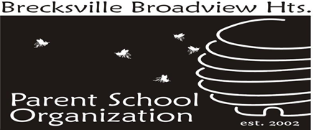

BBHHS PSO AFTER PROM FUNDRAISER
April 12, 2021 – April 26, 2021

Q: WHAT IS A NO FUSS FUNDRAISER?
A: A No Fuss Fundraiser is an easy, hassle-free, opportunity for parents, grandparents, businesses, friends and family to help support our BBHHS After Prom event at Fun n Stuff where we provide a safe and fun event immediately following Prom.

Q: HOW CAN I HELP?
A: You can help by providing a High School PSO After Prom donation. All personal donations will be kept confidential. Please ask your employer if they make matching donations. We’ll be sure to thank them on our website and in communications to the high school families.

Q: WHAT ARE WE FUNDING THIS YEAR?
A: Offset the costs of renting Fun-n-Stuff for the evening, plus food, prizes, and bingo supplies. This is a fun and SAFE way for our students to continue the festivities of the night. We have the entire facility just for our students to enjoy!

Q. ARE THERE ANY OTHER BENEFITS TO DONATING?
A: There sure are!
- For every $25.00 reached in donations for a student they will be entered into a raffle to win a pair of Prom and After Prom Tickets.
- For every $50.00 reached in donations for a student a family name can be entered into a raffle for VIP View at the 2021 Commencement (priceless). (maximum number allowable seats will be awarded)
- You can also choose to not contribute towards the raffle and receive confirmation of this donation for tax purposes. (see notes below)

Q: HOW DO YOU DONATE TO THE FUNDRAISER?
A: It’s simple! During our Fundraiser, you can donate ONLINE using PayPal. You do not have to have an account with PayPal to use this option to make a donation. You can also send a check to: BBHHS PSO After Prom Fundraiser, ℅ BBH High School, 6380 Mill Rd., Broadview Hts., Ohio 44147

Q: WHO CAN I CONTACT WITH QUESTIONS?
A: You can contact Megan Sarfi at: BBHHSpsopresident@gmail.com.

*Contributions may be deductible to the extent permitted by law. Please consult your tax adviser for details.

**If your donation is under $250.00, the receipt that is automatically generated by Constant Contact is what should be used for tax purposes. If your donation exceeds $250, a letter will be mailed to you for tax purposes.

